ARE YOU ELIGIBLE FOR A FREE FLU VACCINE THIS YEAR?

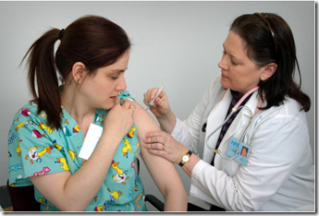

Are you aged 65 or over?
Do you suffer with any of the following conditions?
Asthma; Chronic obstructive pulmonary disease (COPD) or other respiratory conditions
Chronic heart disease Severe mental illness chronic kidney disease
Chronic liver disease Diabetes Epilepsy
Chronic neurological disease such as Parkinson’s disease, motor neurone disease
Asplenia or dysfunction of the spleen
Immunosuppression due to disease such as HIV/AIDS or treatment such as cancer treatment
Do you have a learning disability?
Do you have a Body Mass Index (BMI) of 40 or above and are aged 16 or over?
Do you live with someone who is immunocompromised?
Are you pregnant? Are you homeless? Are you a carer?
Do you work with poultry?
Are you a member of a voluntary organisations providing planned emergency first aid or a Community First Responder?

If you do, you qualify for a FREE flu injection at the practice.
PLEASE CONTACT THE SURGERY ON 01443 442902 TO ARRANGE AN APPOINTMENT
WEEKEND APPOINTMENTS ALSO AVAILABLE
SATURDAY 4 OCTOBER
SUNDAY 5 OCTOBER

