Is your child age 2 – 3 years old?

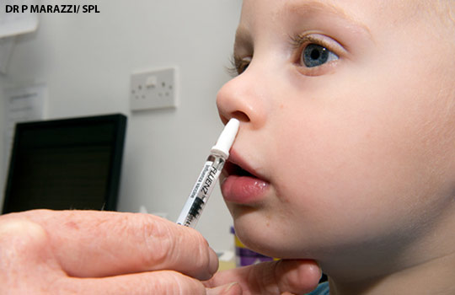

If the answer is yes, your child qualifies for a nasal flu vaccination. Please contact the surgery on 01443 442902 to arrange an appointment
WEEKEND APPOINTMENTS ALSO AVAILABLE
SATURDAY 4 OCTOBER
SUNDAY 5 OCTOBER

